FEATURES
Miniature size
Collimated straight beam
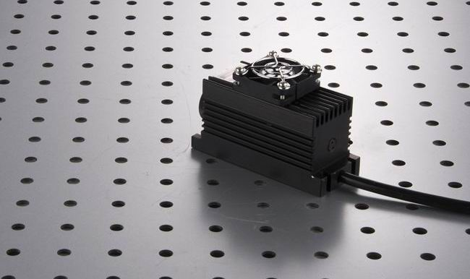
Adjustible focuse
Easy use & maintenance free
Longlife operation
High efficiency
High reliability

APPLICATIONS
Thermal printing
Material Inspection
Scanning Biochemistry
Lidar
Specifications

Model No. | LSR808NL
Wavelength | 808(+/-5) nm
Spatial Mode | multimode
Output Power | 500, 800,…3000mW
Operation Mode | CW or Modulation
Polarization | 10:1
Pointing Stability | <0.05 mrad
Beam Size | 6 mm
Beam Divergence | 2.5 mrad
Power Stability* | <±3% per 2 hrs
Beam Height | 25mm
Temperature Stabilizing | TEC
Warm Up Time | <5 minutes
Beam Quality (M²) | <2
Optimum Operating Temperature | 20~30ºc
Storage Temperature | 10~50ºC
MTTF** | 10,000 hrs
Laser head dimensions | 100(L)x40(W)x50(H)mm3
Power Supply | A. OEM type  LSR-PS-I: 100(L)x58(W)x32(H)mm3  AC/DC PSU: 85~265V 50/60Hz input
Power Supply | B. Lab type  LSR-PS-IIS: 104(W)x128(D)x89(H)mm3  85~265V 50/60Hz input
Power Supply | C. Lab Adjustable type  LSR-PS-IIS: 179(W)x148(D)x56(H)mm3  85~265V 50/60Hz input
Modulation | 0~30khz Analog or TTL

A. OEM type power supply LSR-PS-I+5V PSU
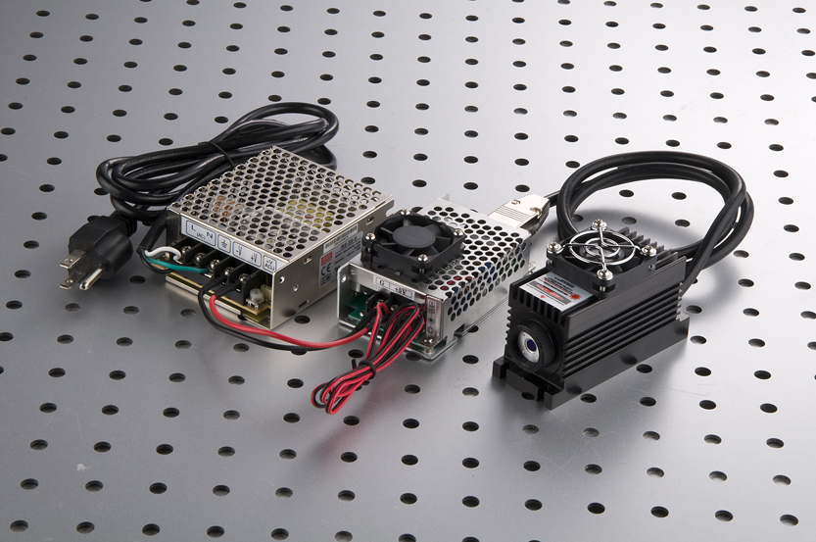

B. Lab type power supply LSR-PS-IIS
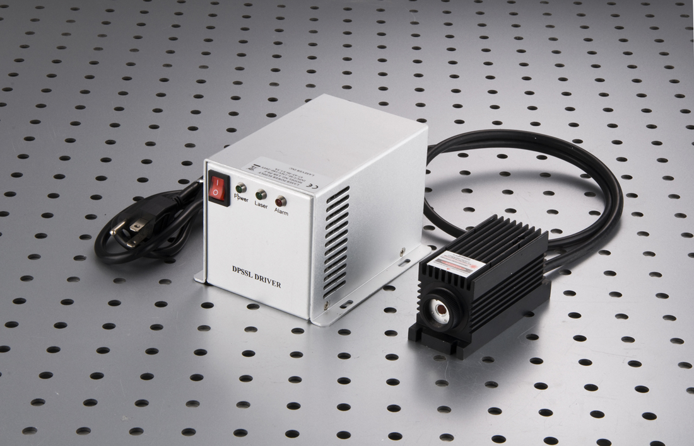

C. Lab Adjustable power supply LSR-PS-II
